12th Geneva Conference on Person Centered Medicine
Summary Report
Jon Snaedal
President, International College of Person Centered Medicine (ICPCM)

Preparations
The Board of the ICPCM suggested Prof. Robert Cloninger from St. Louis, USA to become the Program Director for this event and he graciously accepted. The theme was chosen as ““Promoting well-being and overcoming burn out”. This came as a natural follow up of previous conferences where well-being has been a prominent issue. Furthermore, it has been evident in recent years that burn-out amongst health professionals has become a real threat, not only to those that are being inflicted by the situation but also to those who rely on service provided by these professionals. This is not a new phenomenon but has been increasing in prevalence throughout the world in recent years and is therefore gaining increased attention. Health authorities have recognized these problems and are concerned but the solutions they generally propose to solve the problem seem not be very efficient. A great emphasis is on increasing resilience of health professionals and to adopt methods to help those already having signs of burn-out or that have even entered into the full blown situation. A reflection of the cause of burn-out and thereby the root to the solution is found in the preamble of the Declaration adopted by the Board of ICPCM following the event (see in more detail later): “Burnout is caused by a variety of dehumanizing processes in which there is a gap between who a person is and what they are required to do”. Furthermore, this is stated at the end of the preamble: “Effective improvement in the well-being cannot succeed without recognizing that the foundation for well-being in healthcare is respect for the intrinsic dignity of every person. Medical institutions initially tried to minimize or ignore the toxicity of organizational environments in which medical students and practitioners must operate. Hospitals and medical schools tried to improve the resilience of healthcare providers to stress, rather than admitting the need to change toxic organizational conditions. Unfortunately, there has been little benefit from such efforts because the fundamental problem was not addressed. Specifically, person-centered healthcare and people-centered healthcare systems are essential for promoting well-being and overcoming burnout.”
These reflections that now are found in the last Geneva Declaration of ICPCM became the foundation of the content of the12th Geneva Conference on Person Centered Medicine.
The Program director had several teleconferences with the Board of the ICPCM that thereby formed the organizing committee for the conference. In addition, there were communications with WHO on the content and as in earlier conferences, there was an involvement by officers of WHO at this event as well.
The World Medical Association (WMA) gave a valuable contribution providing the conference with their own staff for practical services. Its president and CEO participated in the conference and one of the members of WMA, the Japanese Medical Association, sent a small delegation.

Practical arrangements and reflections from participants

A new venue was chosen for this event, the main conference hall of the World Council of Churches, which is situated nearby the headquarters of WHO in Geneva. There was a general satisfaction with the venue as everyone got a seat at a circular table which is much more acceptable for participants at such an event than a classical auditorium. Furthermore, it was decided to have the whole conference composed of plenary, without parallel sessions. For this reason, all of the participants had the same experience and this created a sense of unity. The third generally very well accepted change was to have interactive poster sessions that created lively dialogue with each poster presenter. All of this was well reflected in the post conference survey.

Pre-conference work meetings

As usually, the Board with invited external advisers met for a half day workshop in the day preceding the main conference. This took place at the premises of the World Psychiatric Association located at the Geneva University Psychiatric Hospital at Chemin du Petit Bail-Air in Geneva. The main topics of these meetings were the further development of an ICPCM Educational Program on Person Centered Care with the main emphasis on publications from the special session on this topic at the 6th International Congress on PCM in New Delhi in November 2018. Another main topic concerned the further development of ICPCM Person centered diagnosis. At the end, there was an editorial board meeting of the International Journal of PCM and lastly a formal Board meeting of the ICPCM.

The core conference
There were seven plenary sessions and in addition to that, four interactive poster sessions, an experiential session on arts and person centered medicine, and on the last day, a WHO Special Session on self-care and wellbeing.
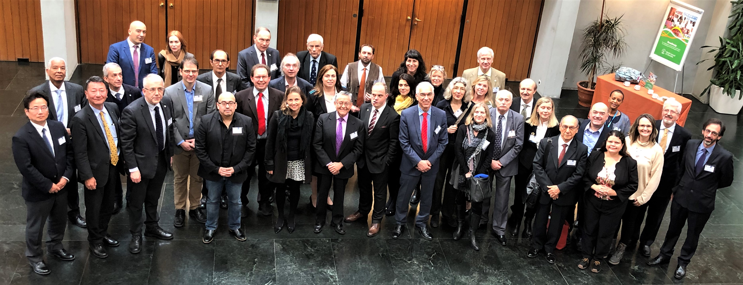A group of participants at the 12th Geneva Conference on Person Centered Medicine
At the first symposium titled What is Well-being and what are the Causes of Well-being and Ill- being? the theoretical framework for the problem was laid out with philosophical perspectives (Fernando Lolas, Chile), biological perspectives (Robert Cloninger, USA), psychological perspectives (Ihsan Salloum, USA) and social and anthropological perspectives (Rsshid Bennegadi, France).
This was followed by the second symposium that included perspectives from the medical profession. Leonid Eidelman, the current President of the WMA, who has made physician burn-out a major theme for his presidency, gave a presentation on his views of this crisis in medicine. He described the three pillar approach to the problem and that all of them need to be attended to. His views fit very well with the views reflected in the Declaration of the conference. In this session, there was also a detailed account of the crisis in Japan, given by Dr. H Hoshi from the Japanese Medical Association (JMA). Informal discussions with Dr. Hoshi and Mr. Noto from JMA have now resulted in a decision made by the President of the JMA, Dr. Yokokura, to host in Japan the 7th International Congress of Person Centered Medicine 1-2. November 2019. Lastly, perspectives from the earliest and last phases of life were given by Dr. Jim Appleyard (UK) and Dr. Jon Snaedal (Iceland), a pediatrician and a geriatrician respectively and both former presidents of WMA.
The burn-out crisis is found not only amongst physicians but also amongst other health care professionals. This was specifically discussed in the third symposium, “Burn-out in other Health Professionals.” There were presentations focusing on nursing (Alessandro Stievano, ICN, Geneva), midwifery (Asiya Odugleh-Kolev, WHO, Geneva), medical scientists (Lembit Rago, CIOMS, Geneva), social scientists (Ottomar Bahrs, Germany), and educators (Kevin Cloninger, USA).
The fourth symposium was on “Major Contributors to Healthy Life Styles and Burn-out Management”. There was a presentation from WHO, on “Nutrition” by Diana Estevez, and three others dealing with contributions from physical activities (Mike Gwerder, Zurich), stress management (Danilo Garcia, Gothenburg), and health promotion coaching (Kevin Cloninger, St Louis).
The fifth symposium was on “Health Professionals Training in Health Promotion and Burn-out Prevention”. Dr. Simone Hauck (Brazil) discussed the urgent need for “Medical curriculum reform”. Tesfamicael Ghebrehiwet (Canada) focused on “Inter-professional training” as means to engage together professionals from different disciplines, breaking customary silos. From Imperial College in London came Austen El-Osta who stressed the importance of self-care for health promotion. Then, Juan Carlos Ocampo from Lima presented trainee and early career physician perspectives on burn-out. The last presentation in this session was given by Bea Albertmann, a medical student leader from Switzerland and representative of the International Federation of Medical Students’ Associations (IFMSA), who offered an inspiring talk on the session’s topic.
The sixth plenary symposium was on “Research and Innovation on Organizational Reform and Integrated Health Promotion, Well-being and Burn-out”. The first presentation was made by Salman Rawaf, director of the WHO Collaborative Center at Imperial College, London, on “Organizational reform for health promotion and burn-out prevention.” The other three presentations were given by Kristina Stoyanova and Drossi Stoyanov (Bulgaria) on “Models of vulnerability and resilience to burn-out: Trans-paradigm approach to comparison of systems and methods”; Robert Cloninger (USA) on “Integrative research for health promotion”; and Levent Kirisci, Juan Mezzich and Ihsan Salloum (USA) on “Measuring well-being: Statistical machine learning approaches”.
In the last plenary symposium, on “Health promotion and burn-out management across the world”, there were accounts from Africa (Werdie van Staden, Pretoria), Asia (Roy Kallivayalil (Kerala, India), Latin America (Alberto Perales, Lima), and Europe (Helen Millar, Scotland). Burn-out is evidently a world-wide problem, cutting across geographic and economic resource levels.
Manjulaa Narasimhan from WHO organized a special WHO session on Self-care and Well-being. Her team as well as WHO officer Asiya Odugleh-Kolev presented WHO perspectives on these matters. In addition, Austen El-Osta from Imperial College London discussed “Self-care in the context of workplace health promotion” and Jim Appleyard (UK) presented broad views on the importance of self-care for wellbeing in primary care settings.
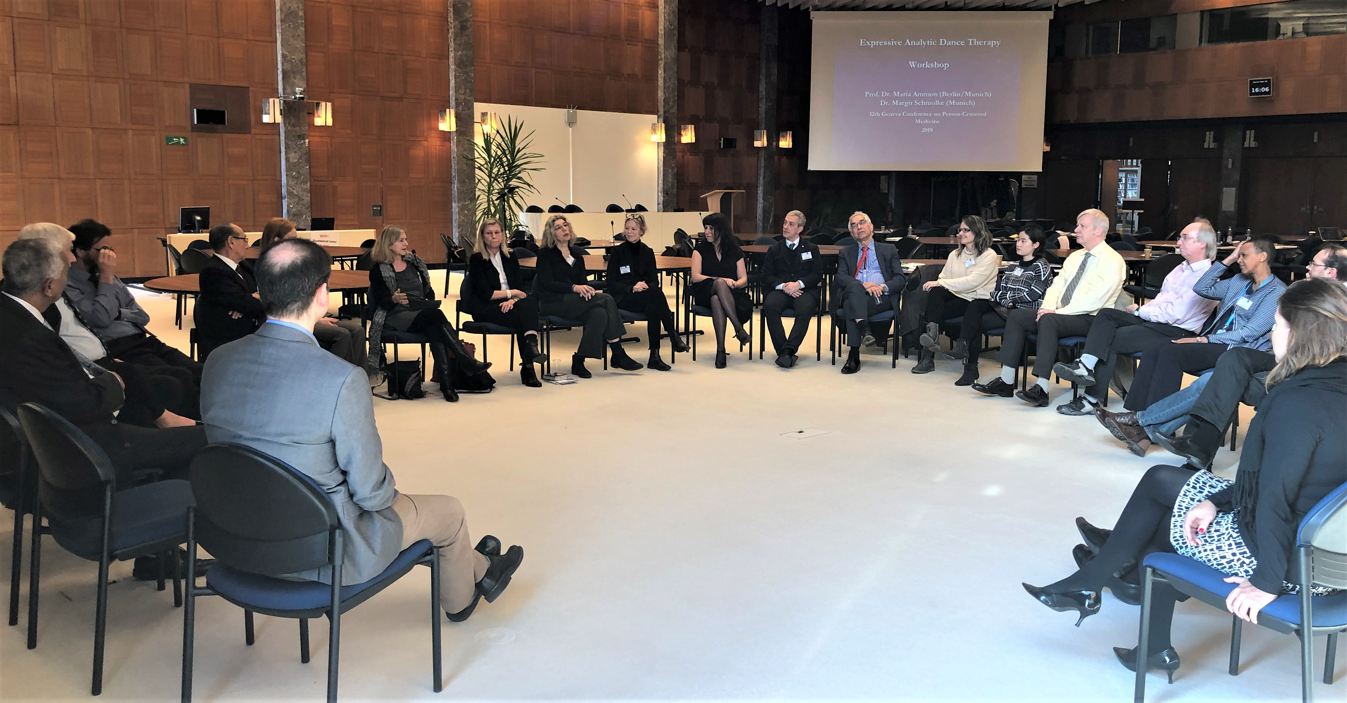Participants in the experiential Arts and Person Centered Medicine Session, 12th Geneva Conference.

As can be seen from this rather superficial overview, a wide range of topics under the umbrella theme of well-being and burn-out were covered. We as organizers are pleased to read the participants post-conference evaluation, indicating that the event was “well-organized, including high quality, interesting and engaging presentations, with enthusiastic participation of the audience and a warm collegial atmosphere.”
The 2019 Paul Tournier Prize
This eminent ICPCM prize, supported generously by the Paul Tournier Association, was given out at the Geneva Conference for the third time. A jury composed of representatives from the ICPCM and the Paul Tournier Association selected as Prize winner, from a strong group of international nominees, Prof. Juan Alberto Perales-Cabrera from Lima, Peru. He has carried-out outstanding educational and research work on humanization of health care and pioneered the development of the Latin American Network of Person Centered Medicine. At the special ceremony (which was also attended by Paul Tournier’s grand-son Alain Tournier), Professor Perales offered an inspiring lecture on the current status and future horizons of person centered medicine in Latin America.
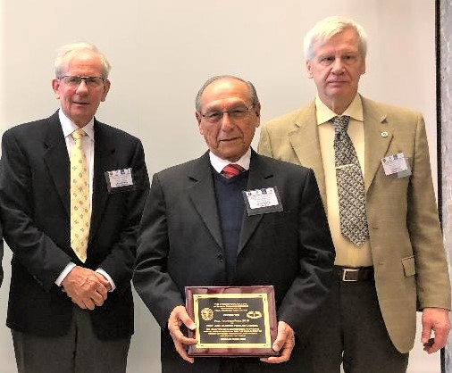
[LtoR] Dr. Fredric Von Orelli, Prof Juan Alberto Perales-Cabrera and Prof Jon Snaedal at the 2019 Paul Tournier Prize Ceremony, 12th Geneva Conference on Person Centered Medicine.
The 2019 Geneva Declaration
The 2019 Geneva Declaration on Promoting Well-being and Overcoming Burn-out was drafted prior to the conference by its program director, Prof. Robert Cloninger, and then discussed thoroughly during the 12th Geneva Conference, including at the ICPCM General Assembly.

The Declaration contains a preamble that at its end reads: “The 12th Geneva Conference on Person-centered Medicine issues the following recommendations, all based on establishing person-centered healthcare as the foundation for promoting well-being in individuals, organizations, and society as a whole”. This is followed by ten recommendations, the last one stating that “Persons-centered transformations are relevant not only to the health field but to all areas of social life where humanization is of paramount importance. Such inter-sectorial coordination is integral to the attainment of the Sustainable Developmental Goals proclaimed by the United Nations in 2015.”

The Declaration will be published on the web-site and journal of ICPCM and will be distributed widely, including to our many collaborating organizations.

